1. To create the server application, we need to create the instance of ServerSocket class. Here, we are using 6666 port number for the communication between the client and server. You may also choose any other port number. The accept() method waits for the client. If clients connects with the given port number, it returns an instance of Socket.

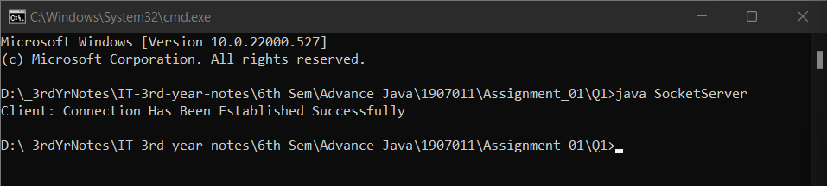

Output at Server (SocketServer.java)

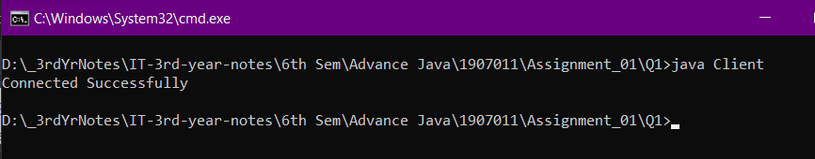

Output at Client(Client.java)

2. Client will write first to the server then server will receive and print the text. Then server will write to the client and client will receive and print the text.

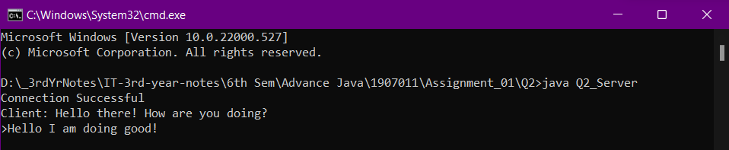

Output at Server (Q2_Server.java)

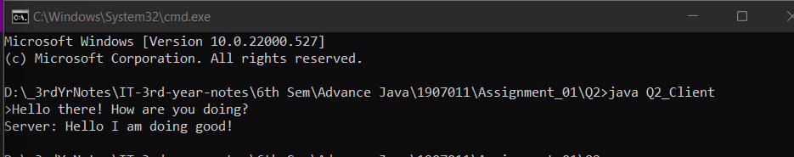

Output at Client (Q2_Client.java)

3. The URLConnection class provides many methods. We can display all the data of a webpage by using the getInputStream() method. It returns all the data of the specified URL in the stream that can be read and displayed.

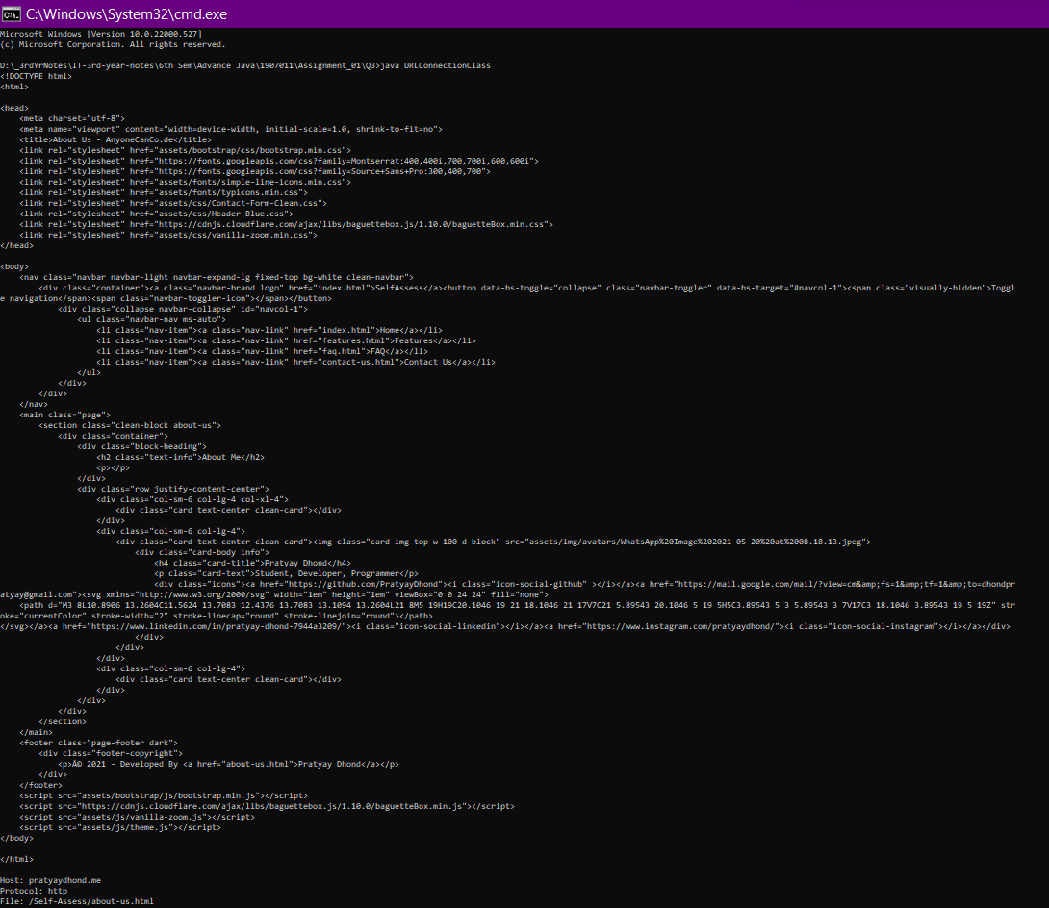

Output (full output)

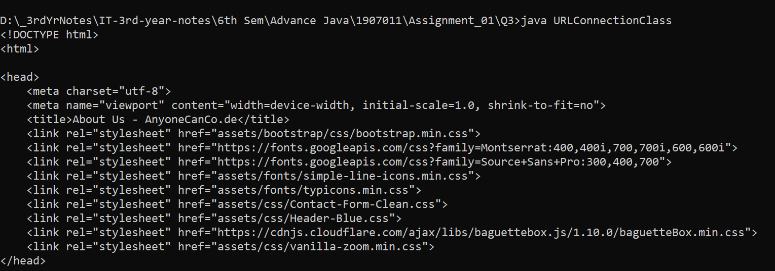

Output (part 1)

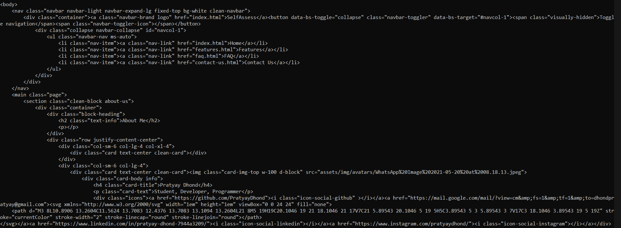

Output (part 2)

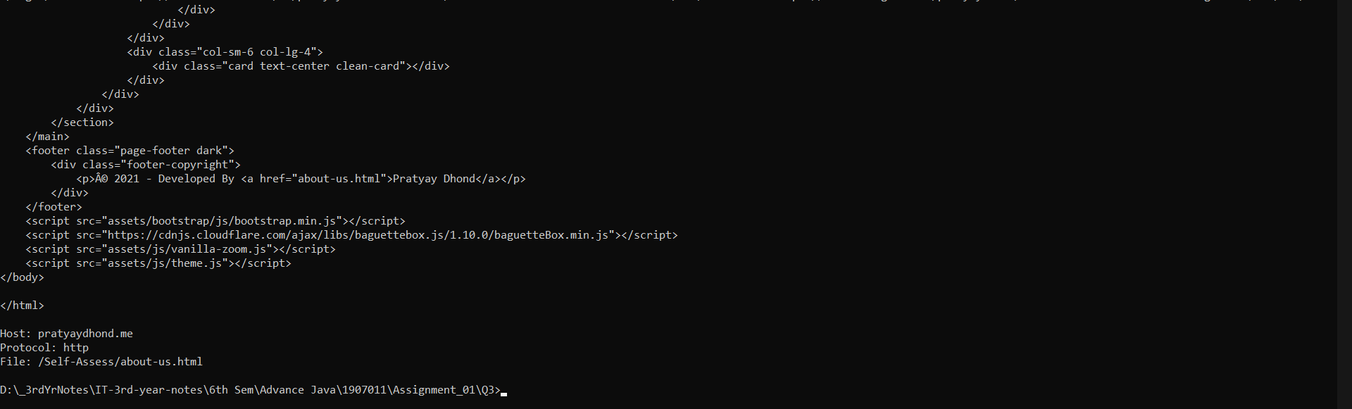

Output (part 3)

4. Simple example of InetAddress class to get ip address of www.javatpoint.com website.

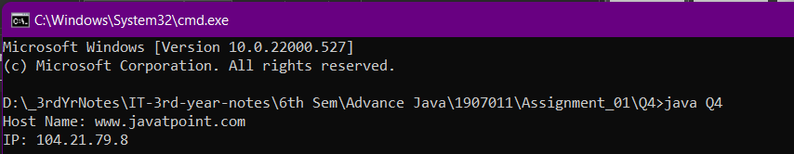

Output Q4.java

5. Sending and receving DatagramPacket by DatagramSocket.

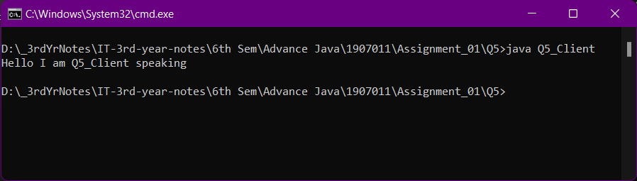

Sending datagramPacket (Q5_client.java)

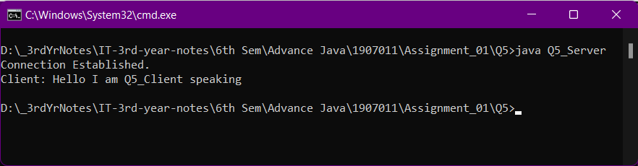

Receiving datagramPacket (Q5_server.java)